EAPS 520 – Assignment #1

Question 1:

Session Proposals

1. I didn’t find where the session proposals were. Nor could I find where the “Type” section was. All that I found was “Type” when I clicked on an abstract that told me whether it was oral, a poster, etc.

b) Abstracts

2021

1. A11B - Atmospheric Aerosols and Their Interactions With Clouds, Radiation, and Climate on Regional Scale I Oral

* Atmospheric aerosols, which are formed, transformed, and removed through complex physicochemical processes, have profound impacts on human health. Besides, they affect meteorology and climate by interacting with clouds, radiation, and precipitation. Changes in meteorology and climate, in turn, influence the budget and lifecycle of aerosols.
* We welcome all theoretical, observational, experimental, and modeling studies that present new knowledge of aerosols and aerosol-climate interactions on the regional scale. Relevant topics include but are not limited to: (1) Sources, formation, evolution, and removal of aerosols, including inorganic and organic aerosols. (2) Aerosol physical and chemical processes that affect radiation and clouds, including new-particle formation and growth, cloud condensation and ice nucleation activities, multiphase chemistry, etc. (3) Interactions among aerosols, radiation, liquid-, mixed-, and ice-phase clouds, and precipitation. (4) Impact of these interactions on weather, climate change, and air pollution. (5) influence of meteorology and climate change on aerosols and air quality.

1. A12D - Bridging the Gap From Climate to Extreme Weather: Observations, Theory, and Modeling I Oral

* There is a growing need to understand how extreme weather phenomena will change in the future under climate change. Such a goal requires insight into how such phenomena, including but not limited to severe thunderstorms, tornadoes, hurricanes, and extreme precipitation, emerge within the climate system in general. This session seeks novel research bridging the gap between climate and extreme weather with an emphasis on understanding both the underlying climate physics that generate such events and the mechanisms by which their statistics vary across climate states, including global warming. Analyses employing a wide range of methodologies are welcome, including idealized and high-resolution climate modeling, observational and historical data analysis, and theory.

1. A25T - Convection Processes and Their Environmental and Aerosol Interactions: Theory, Observation, and Modeling II Poster

* Convective clouds play an important role in the global energy balance through vertical transport and a redistribution of water and energy. Accurately simulating convective clouds in state-of-the-art models remains extremely challenging, even for fundamental convective characteristics such as the diurnal cycle, strength, and depth of convection. In this session, we will highlight research aimed at improving our understanding of fundamental processes of shallow and deep convection including, but not limited to kinematics, microphysics, entrainment and detrainment, turbulent mixing, precipitation, and cold pool processes and their interactions with environmental thermodynamics and dynamics, radiation, and aerosols. The session invites theoretical, observational, experimental, and modeling studies that advance the process-level understanding of convection and its representation in models.

2020

1. A010 - Ice Multiplication: Theory, Formulations, and Microphysical/Electrical Role from Cloud Scale to Global Scale I Posters

* Various types of fragmentation of ice in precipitating cold clouds create positive feedbacks whereby fragments grow to become precipitation that then fragments again. This ice multiplication produces high concentrations of ice at a drastic rate. Explosive growth of ice concentrations controls the eventual microphysical and radiative properties of cold clouds.
* In the last decade, fragmentation of ice and its ramifications for the nonlinear cloud-microphysical system have been the focus of laboratory experiments and modeling. New ideas have emerged about repercussions for charge separation in ice-ice collisions in thunderstorms. If ice crystals, many of which are secondary in origin, control charging, ice multiplication may influence lightning
* This session will provide a forum for exchange of ideas on such issues at this inter-disciplinary frontier of knowledge. Presentations are encouraged about effects from ice multiplication on clouds on diverse spatial scales ranging from the cloud-scale up to the mesoscale and even global scale.

1. A007 - Dust in a Changing Climate: From Small-Scale Insights to Large-Scale Understanding IV Posters

* Interactions of the dust cycle with components of the changing Earth system produce a wide range of complex effects on, for instance, atmospheric composition, the hydrological cycle, climate, and ecosystems. To better understand and assess these effects, advances are needed in field and laboratory measurements, remote sensing techniques, and models of dust properties. This session invites studies reporting such advances, and results relevant to the NASA Earth Surface Mineral Dust Source Investigation, EMIT, are particularly encouraged. In addition, this session invites studies addressing the dust cycle and its impact on the Earth system. This includes studies of dust source regions, high latitude dust, dust interactions with clouds, radiation, precipitation, the cryosphere, and the biosphere, observational and modeling insights into the variability of dust on different time scales and climate feedbacks, dust impacts on air quality, and modeling studies of the dust cycle and its interactions with other Earth system cycles.

1. A009 - Extreme Precipitation in Past, Present, and Future Climates III Posters

* Precipitation extremes, including heavy snowfall and rainfall, may occur on different time scales ranging from minutes, days to seasons. These extremes can be associated with severe impacts such as flooding, but are also important for water supply as individual events can substantially raise the levels of water reservoirs. This session will focus on precipitation extremes, including their driving dynamic and thermodynamic processes, external drivers, impacts, statistical properties, and changes in their occurrence related to climate variability and climate change. Therefore contributions are invited that investigate precipitation extremes and their impacts under past, present and future climate conditions. This includes studies that aim to understand individual events, the spatial and temporal variability in the occurrence of precipitation extremes, predictability, and long term changes, based on observational data and climate models including atmospheric models at very high resolution. Contributions are also invited that link precipitation extremes with environmental and socio-economic impacts.

2019

1. A11E - Cloud-Aerosol-Precipitation Interactions and Their Parameterizations in the Context of Weather and Climate I

* Over the last decades, studies of cloud-aerosol-precipitation interactions (CAPI) have evolved. These studies have started by focusing on aerosol-induced microphysical changes in cloud-particle sizes, and moved to feedbacks between aerosol, microphysics, thermodynamics, radiation, and dynamics. CAPI studies have also moved from CAPI in a small cloud system or a single cloud to a mesoscale or a larger-scale cloud system for a better understanding of CAPI in the context of weather and climate. With this evolution, the parameterization of CAPI in weather and climate models has evolved, although lack of the understanding of CAPI has slowed down the development of the CAPI parameterization. Hence, this session invites all observational, experimental and modeling studies of CAPI that enhance the understanding of CAPI, and adopt the traditional microphysical approach and/or the recent approach including those feedbacks. Studies associated with the development of the CAPI parameterization and its application to models are also welcome.

1. A51N - Linking Clouds, Convection, and Circulation: Insights from Models, Theory, and Observations III Posters

* Atmospheric moist convection plays crucial roles in circulation & climate. The condensation heating drives atmospheric movement ranging from convective to planetary scale. The cloud-radiative effect is crucial for many dynamic systems, such as the Madden-Julian Oscillation, & remains one of the most uncertain climate feedbacks. Wind-evaporation-SST feedback modulates the evolution of many important phenomena, including ENSO, hurricanes, & monsoons. Despite recent progress, fundamental understanding of interactions between moist process & the large-scale circulation & climate at different spatial/temporal scales remains elusive. This session will explore advances in the coupling between moisture, cloud, circulation, & climate. The related topics include, but not limited to, interactions between convection & large-scale circulations, cloud-radiative & other moisture-involved feedbacks & their implications in climate, responses of convective systems & extreme weather to circulation or climate changes, & so on. Observational, modeling (idealized/comprehensive), & theoretical studies are all welcome.

1. A43S - The Madden-Julian Oscillation and Convectively Coupled Equatorial Waves: Observations, Theory, and Modeling II Posters

* The Madden-Julian Oscillation (MJO) and convectively coupled equatorial waves (CCEWs), including the easterly waves, play an active role in Earthâs hydrological cycle. Our understanding and modeling capability of the MJO and CCEWs still remain rather limited, however.
* In this session, we invite presentations that highlight progress on observational, theoretical, and modeling studies of the MJO and CCEWs, including but not limited to:
* New observations of multi-scale convective organization and interactions among the MJO and CCEWs that provide critical insights into their key mechanisms;
* Seasonal, interannual, decadal, and future changes in MJO and CCEWs characteristics;
* Influences of the MJO and CCEWs on global weather and climate events, locally or remotely;
* Theoretical understanding of essential physics of the MJO and CCEWs;
* Process-oriented diagnostics for simulations of the MJO and CCEWs;
* Efforts towards improved representation of the MJO and CCEWs and their global impacts in climate models.

2018

1. A11D: Data Assimilation, Reanalysis, and Observing System Simulation Experiments: Theory and Applications I

* Data assimilation is a sequential process that incorporates satellite and in-situ observations into a background state (forecast) provided by the NWP models. The model state is then updated and a new forecast is initiated which will be used to provide the background state for the next assimilation cycle. This session is devoted to assimilation of s*paceborne* and conventional observations into NWP models; development, validation, and inter-comparison of reanalysis products; new advanced statistical and mathematical methods for data assimilation; as well as Observing System Simulation Experiments (OSSE) including simulation of realistic observations, validation of Nature Runs, and data assimilation experiments using simulated observations.

1. A11C: Air Pollution, Aerosol, and Climate Interactions in Asia I

* With the densest population and fastest economic growth in the world, Asia is experiencing an unprecedented rate of changes due to both natural and anthropogenic factors. Of particular concern are changes in environment and climate and their connections. Air pollution poses serious health risk to the large population in Asia, unraveling any connections between air pollution and climate is utmost to making sound policies for sustainable development and the well-being of about half of the world’s population. Abstracts are solicited in the following subjects:
* (1) Identifying/quantifying major emission sources;
* (2) New particle formation and growth;
* (3) Cloud condensation and ice nuclei (CCN/IN);
* (4) Surface reactions on aerosol particles;
* (5) Air pollution and boundary-layer interactions;
* (6) Impact of Asian monsoon on air pollution;
* (7) Impact of El Nino, ENSO, PDO, polar on air pollution;
* (8) Air pollution and health;
* (9) Major field campaigns in Asia;
* (10) Air quality modeling

1. A13H: Cloud–Aerosol–Radiation–Climate Interactions in the Southeastern Atlantic II Posters

* Interactions between absorbing aerosol over and near clouds via radiative transfer, direct microphysical contact, or thermodynamic and dynamical processes impact climate. These cloud-aerosol-radiation-climate interactions are prevalent over the southeastern Atlantic, where large planetary low cloud decks, overlaid by biomass burning aerosol layers, occur. These reflective clouds help set the regional large-scale circulation. Smoke above clouds absorbs shortwave radiation and can produce a direct radiative warming when underlain by bright low clouds. The clouds are susceptible to atmospheric aerosol by changes in atmospheric stability and free-tropospheric moisture, and microphysical interactions. Both the low cloud deck and the smoke layer are challenging to measure and simulate at all scales, constituting a major uncertainty in understanding key processes and regional climate. Studies focused on all aspects of observation (in situ and remote sensing) and modeling of interactions between clouds, aerosol, radiation, precipitation, and climate over the southeastern Atlantic are solicited.

2017

1. A21K: The Underappreciated Aerosol Coarse Mode: Dust Sources and Coarse Mode Impacts on Climate and Biogeochemistry I Posters

* The coarse mode tends to be ignored because it is difficult to measure, and the perception that it does not exert a large effect on aerosol forcing or chemistry. However, coarse mode aerosols can have substantial impact on ice nuclei concentrations, on radiative forcing, and when deposited change the biogeochemistry and impact on the carbon cycle. There is a need to assimilate the current state of knowledge about coarse mode aerosol and its influence on climate and biogeochemistry. Factors that must be considered include: (1) variability in dust generation, (2) size-resolved physical, optical and chemical characteristics, and (3) atmospheric processing. This session encourages the presentation of work that addresses these factors in measurements and models. Individual observational studies at specific locations, cross-scales studies, and global modeling synthesis studies are encouraged. Also, this session will focus discussion about our evolving knowledge of the linkages between drought, "natural" and anthropogenic dust emissivity.

1. A14F: Regional Climate Modeling I

* This session focuses on the state of the art in regional climate modeling on seasonal to centennial time scales. Contributions are solicited on coordinated experiments that focus on regional and high resolution global modeling such as CORDEX; novel approaches for model evaluation, especially process-oriented model verification; new developments such as coupled earth system modeling at regional scales and convection-permitting simulations; ensemble methods and uncertainty analyses; and assessing the added value of regional modeling. Results from use of regional models for process understanding and downscaling of IPCC climate change scenarios are also encouraged.

1. A21Q: Stratospheric Ozone Change, Its Impact on Climate and Understanding of Uncertainties in Data Records I

* Stratospheric ozone changes have been shown to have far-reaching impacts on climate through radiative and dynamical effects. Modelling and observational studies have detected the imprint of ozone on changes in the subtropical and midlatitude atmospheric circulation with associated impacts on the ocean circulation, sea ice and regional surface climate. Uncertainties remain in the observed stratospheric changes, the dynamical understanding and magnitude of the climate response to ozone changes and the interplay between ozone recovery and greenhouse gases into the future. Uncertainties in stratospheric and tropospheric ozone trends derived from long-term ozone records, including data produced through merging multiple data sources that have been combined to improve spatial or temporal sampling, or to extend the record in time will be addressed. In preparation for the 2018 WMO/UNEP Ozone Assessment, we invite papers on all aspects of long-term ozone changes and associated climate impacts in both hemispheres and on all timescales.

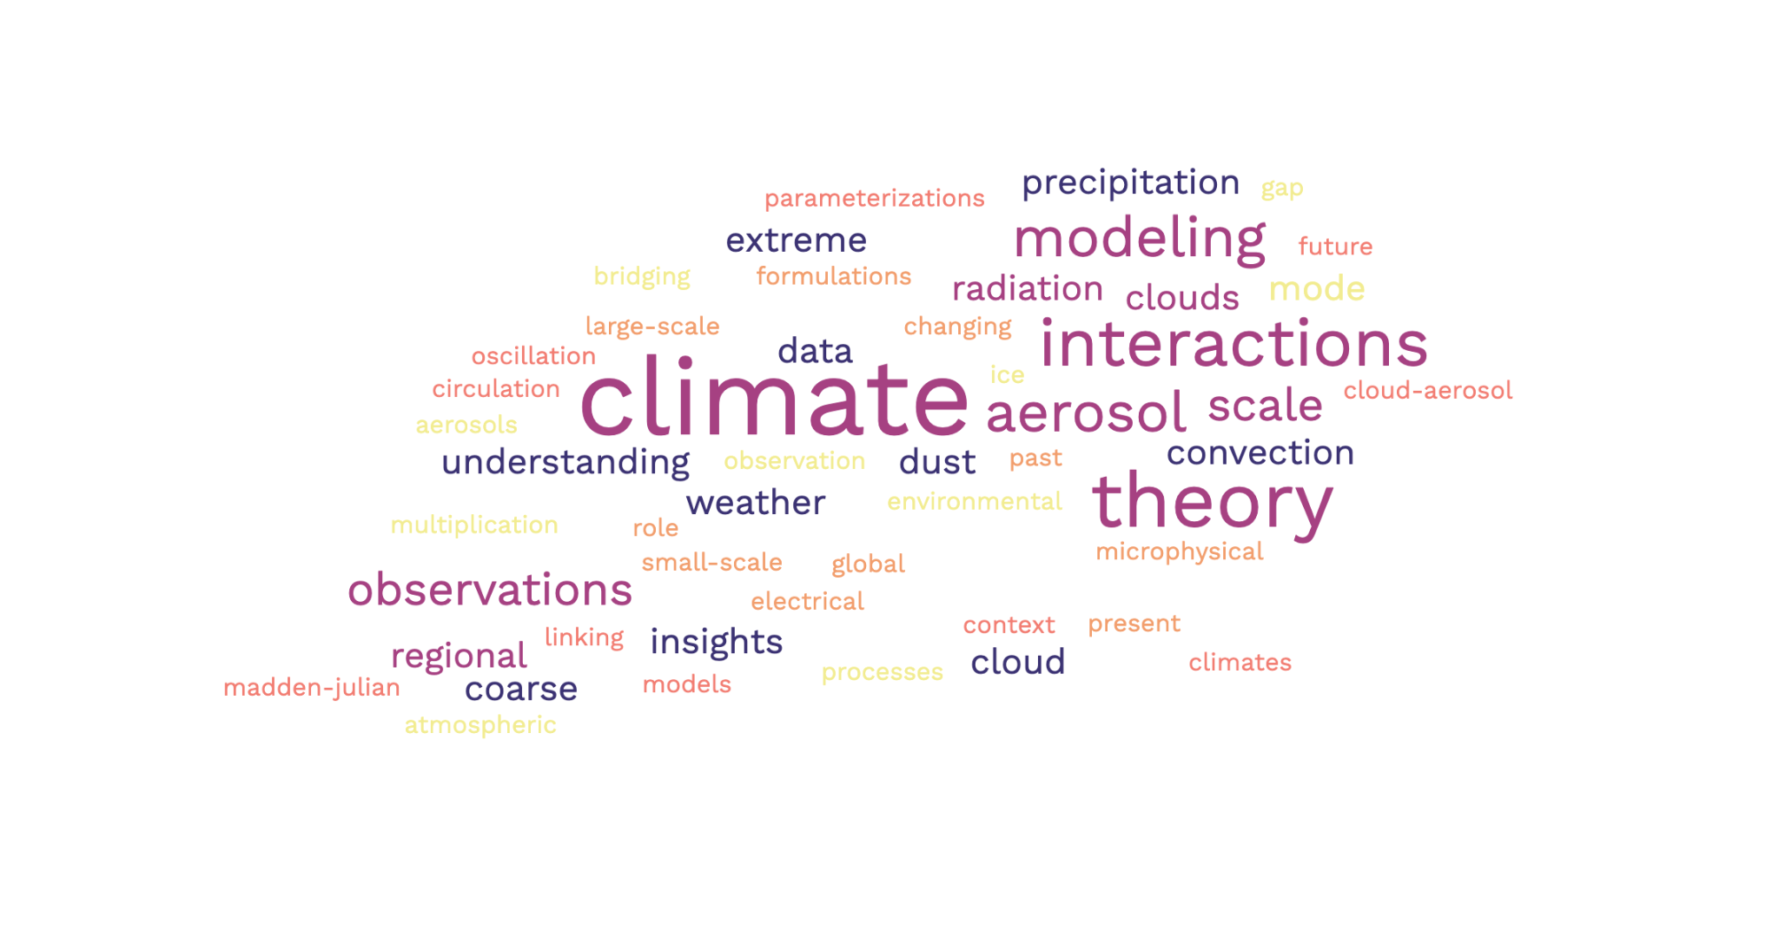

c) I added 5 more abstracts:

2021 (Keyword: Rossby Waves): A42E - Jet-Stream Dynamics, Atmospheric Rossby Waves, and Associated Extreme Weather and Climate Events I Oral

* Recent extreme weather and climate episodes, including the Siberian heatwave of early summer 2020 and the US cold-air outbreak in February 2021, highlight the need to advance understanding of planetary and synoptic-scale atmospheric jetstream and Rossby wave dynamics, in particular their impacts on extreme weather and climate events including predictability. Abstracts are solicited dedicated to:

2020(Keyword: Storms): A151 - Extratropical and High-Latitude Storms, Teleconnections, Extreme Events, and the Rapidly Changing Polar Climate II Posters

* Synoptic storms and large-scale teleconnections are prominent dynamic drivers for daily-to-decadal climate variability in the extratropics and high-latitudes and can interplay with external forcings to contribute to long-term climate change. Storms often bring extreme events, including heavy rainfall or snowfall, high winds, large ocean waves and surges, coastal flooding and erosion, abrupt temperature increases, and rapid sea ice loss. Teleconnections link polar and lower latitude climate and play modulating roles in storm activities. Storms and teleconnections have demonstrated systematic changes, leading to alterations of feedback processes and contributing to anomalous variability and changes of climate. This session provides a venue to present progress on extratropical and high-latitude storm activities, teleconnections between extratropics/tropics and the polar regions, resulting extreme events, and underlying physical processes (e.g. stratosphere-troposphere coupling, Rossby wave and jet stream dynamics, wave-mean flow interactions), along with the rapidly changing polar climate, as well as associated ecosystem- and societal impacts.

2019(Keyword: Storms): A21T - The Dynamics of the Large-Scale Atmospheric Circulation in Past, Present, and Future Climate: Jet Streams, Storm Tracks, Stationary Waves, and Monsoons IV Posters

* Large-scale atmospheric circulation plays a key role in the global climate system. Understanding the fundamental dynamics of the large-scale circulation is essential for constraining regional climate projections under a changing climate. Furthermore, the dynamics of the atmospheric general circulation intimately interact with the energy and hydrological cycles, exerting profound impacts on extreme weather and climate events. Such interactions in both the tropics and extra-tropics occur on a wide range of spatial and temporal scales, which calls for a combination of conceptual understanding, hierarchical modeling, and observations.
* We welcome contributions covering theory, idealized and comprehensive modeling, and novel diagnostic frameworks for observations and CMIP model outputs to improve our understanding of the large-scale atmospheric circulation and how it may respond to future climate change. Contributions including, but not limited to, the ITCZ, monsoons, jet streams, storm tracks, extreme weather events, blocking, stationary waves, and atmospheric rivers are highly encouraged.

2018(Keyword: Dynamics): A51S: Stratosphere–Troposphere Coupling: Large-Scale Atmospheric Dynamics and Transport I Posters

* Numerous studies have shown that stratospheric variability impacts surface weather and climate on timescales ranging from days to decades. In addition, the stratosphere affects tropospheric composition not only through the stratosphere-to-troposphere transport of ozone but also by modulating tropospheric dynamics. This session will cover all aspects of stratospheric dynamics and transport, as well as the two-way coupling between the stratosphere and the troposphere. Examples includes dynamical coupling during stratospheric sudden warming events and stratospheric modulation of the midlatitude jet streams and associated impacts on pollution transport. Studies focusing on tropical interactions are also welcome. Abstracts involving theoretical, modeling, and observational studies of the dynamics, transport, variability, and trends in the stratosphere are encouraged, as well as those investigating the stratosphere's role in setting surface climate and composition in the past, present, and future.

2017(Keyword: ): A31I: Upper Tropospheric Clouds and Convection: Processes, Dynamics, and Feedbacks in Weather and Climate II Posters

* Deep convection, stratiform anvils, and cirrus clouds all play significant roles in controlling the energy budgets and climate feedbacks. With advances in high-resolution modeling and the wealth of observations available, much progress has been made in understanding the nature of upper tropospheric clouds and convection. Recently, GEWEX has formed a working group on Process Evaluation Studies on Upper Tropospheric Clouds and Convection (UTCC PROES) to develop new observation based metrics to advance our understanding on the relation between convection and outflowing anvil properties, in particular their radiative heating, and resulting feedbacks.Motivated by this, we invite presentations on recent findings on UTCC and their dynamics and feedbacks at the process level. Both observational and modeling studies are encouraged to participate. In particular we invite submissions on various aspects of convective systems including links between precipitation, anvil and cirrus cloud dynamics, latent and radiative heating, and upscale feedbacks.

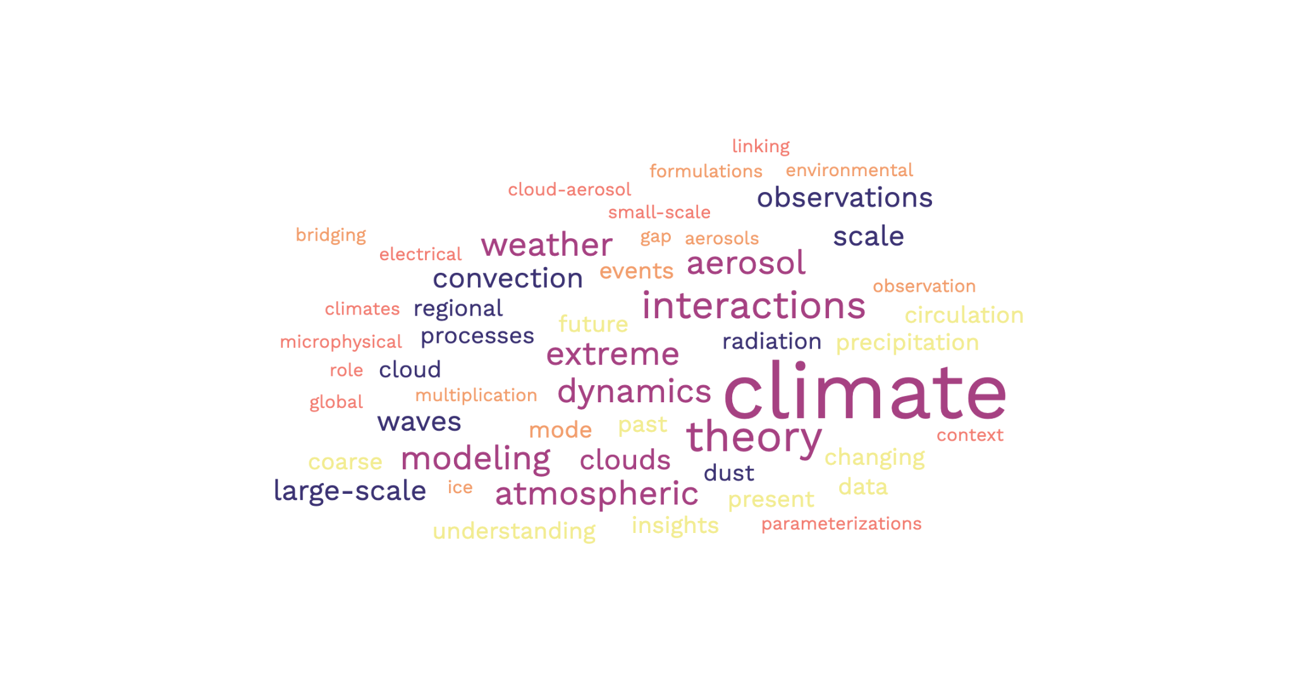

d) besides the obvious “climate” in the word clouds, other ones that also pop up to me are “aerosol”, “interactions”, and “modeling”.This doesn’t tell me much on its own, as some of the words like “interaction” can mean interaction between many different things. However, it does give me an idea of what the climate science community is talking about. Interestingly enough, “dust” is not too big on the word clouds. This could simply be from the fact that I didn’t look at every single one and so happened to miss the abstracts that included dust. I did think it would be a lot bigger though.

Question 2:

1. I just accessed it the same way it said in the HW
2. I chose the data “1979_01-03_z.nc”.

* Output:
* netcdf \1979_01-03_z {
* dimensions:
* longitude = 240 ;
* latitude = 121 ;
* levelist = 37 ;
* time = UNLIMITED ; // (360 currently)
* variables:
* float longitude(longitude) ;
* longitude:units = "degrees_east" ;
* longitude:long_name = "longitude" ;
* float latitude(latitude) ;
* latitude:units = "degrees_north" ;
* latitude:long_name = "latitude" ;
* int levelist(levelist) ;
* levelist:units = "millibars" ;
* levelist:long_name = "pressure_level" ;
* int time(time) ;
* time:units = "hours since 1900-01-01 00:00:0.0" ;
* time:long_name = "time" ;
* short z(time, levelist, latitude, longitude) ;
* z:scale_factor = 7.62982684032229 ;
* z:add_offset = 244183.15142316 ;
* z:_FillValue = -32767s ;
* z:missing_value = -32767s ;
* z:units = "m**2 s**-2" ;
* z:long_name = "Geopotential" ;
* // global attributes:
* :Conventions = "CF-1.0" ;
* :history = "2012-05-14 18:01:37 GMT by mars2netcdf-0.92" ;
* }

1. My code:

* import numpy as np
* from [scipy.io](http://scipy.io/) import netcdf
* import matplotlib.pyplot as plt
* # read in the file, and the three dimensional data z is stored in your chosen data
* f = netcdf.netcdf_file("/depot/eapsdept/data/ERA_Interim/filename",'r')
* z = f.variables['t']
* time = f.variables['time'].data
* lat = f.variables['latitude'].data
* lon = f.variables['longitude'].data
* f.close()
* # now let us plot the pattern of the first day
* plt.figure(1)
* plt.contourf(lon,lat,z[240,121,:,:],cmap='RdBu_r');
* plt.colorbar()
* plt.title('surface air temperature’)
* plt.xlabel('longitude')
* plt.ylabel('latitude')
* I kept getting an error in my first line of code.The error:
* kelshark@brown-fe02:**/depot/eapsdept/data/ERA_Interim** $ import numpy as np
* import: unable to open X server `' @ error/import.c/ImportImageCommand/369.
* I’ve tried all I can, but it still isn’t helping at all. It gives me this error with all the “import” functions. Jupyter notebook finally opened for me, but it didn’t allow me to view anything. I was able to enter the the ERA, but that was it. It didn’t let me go further.

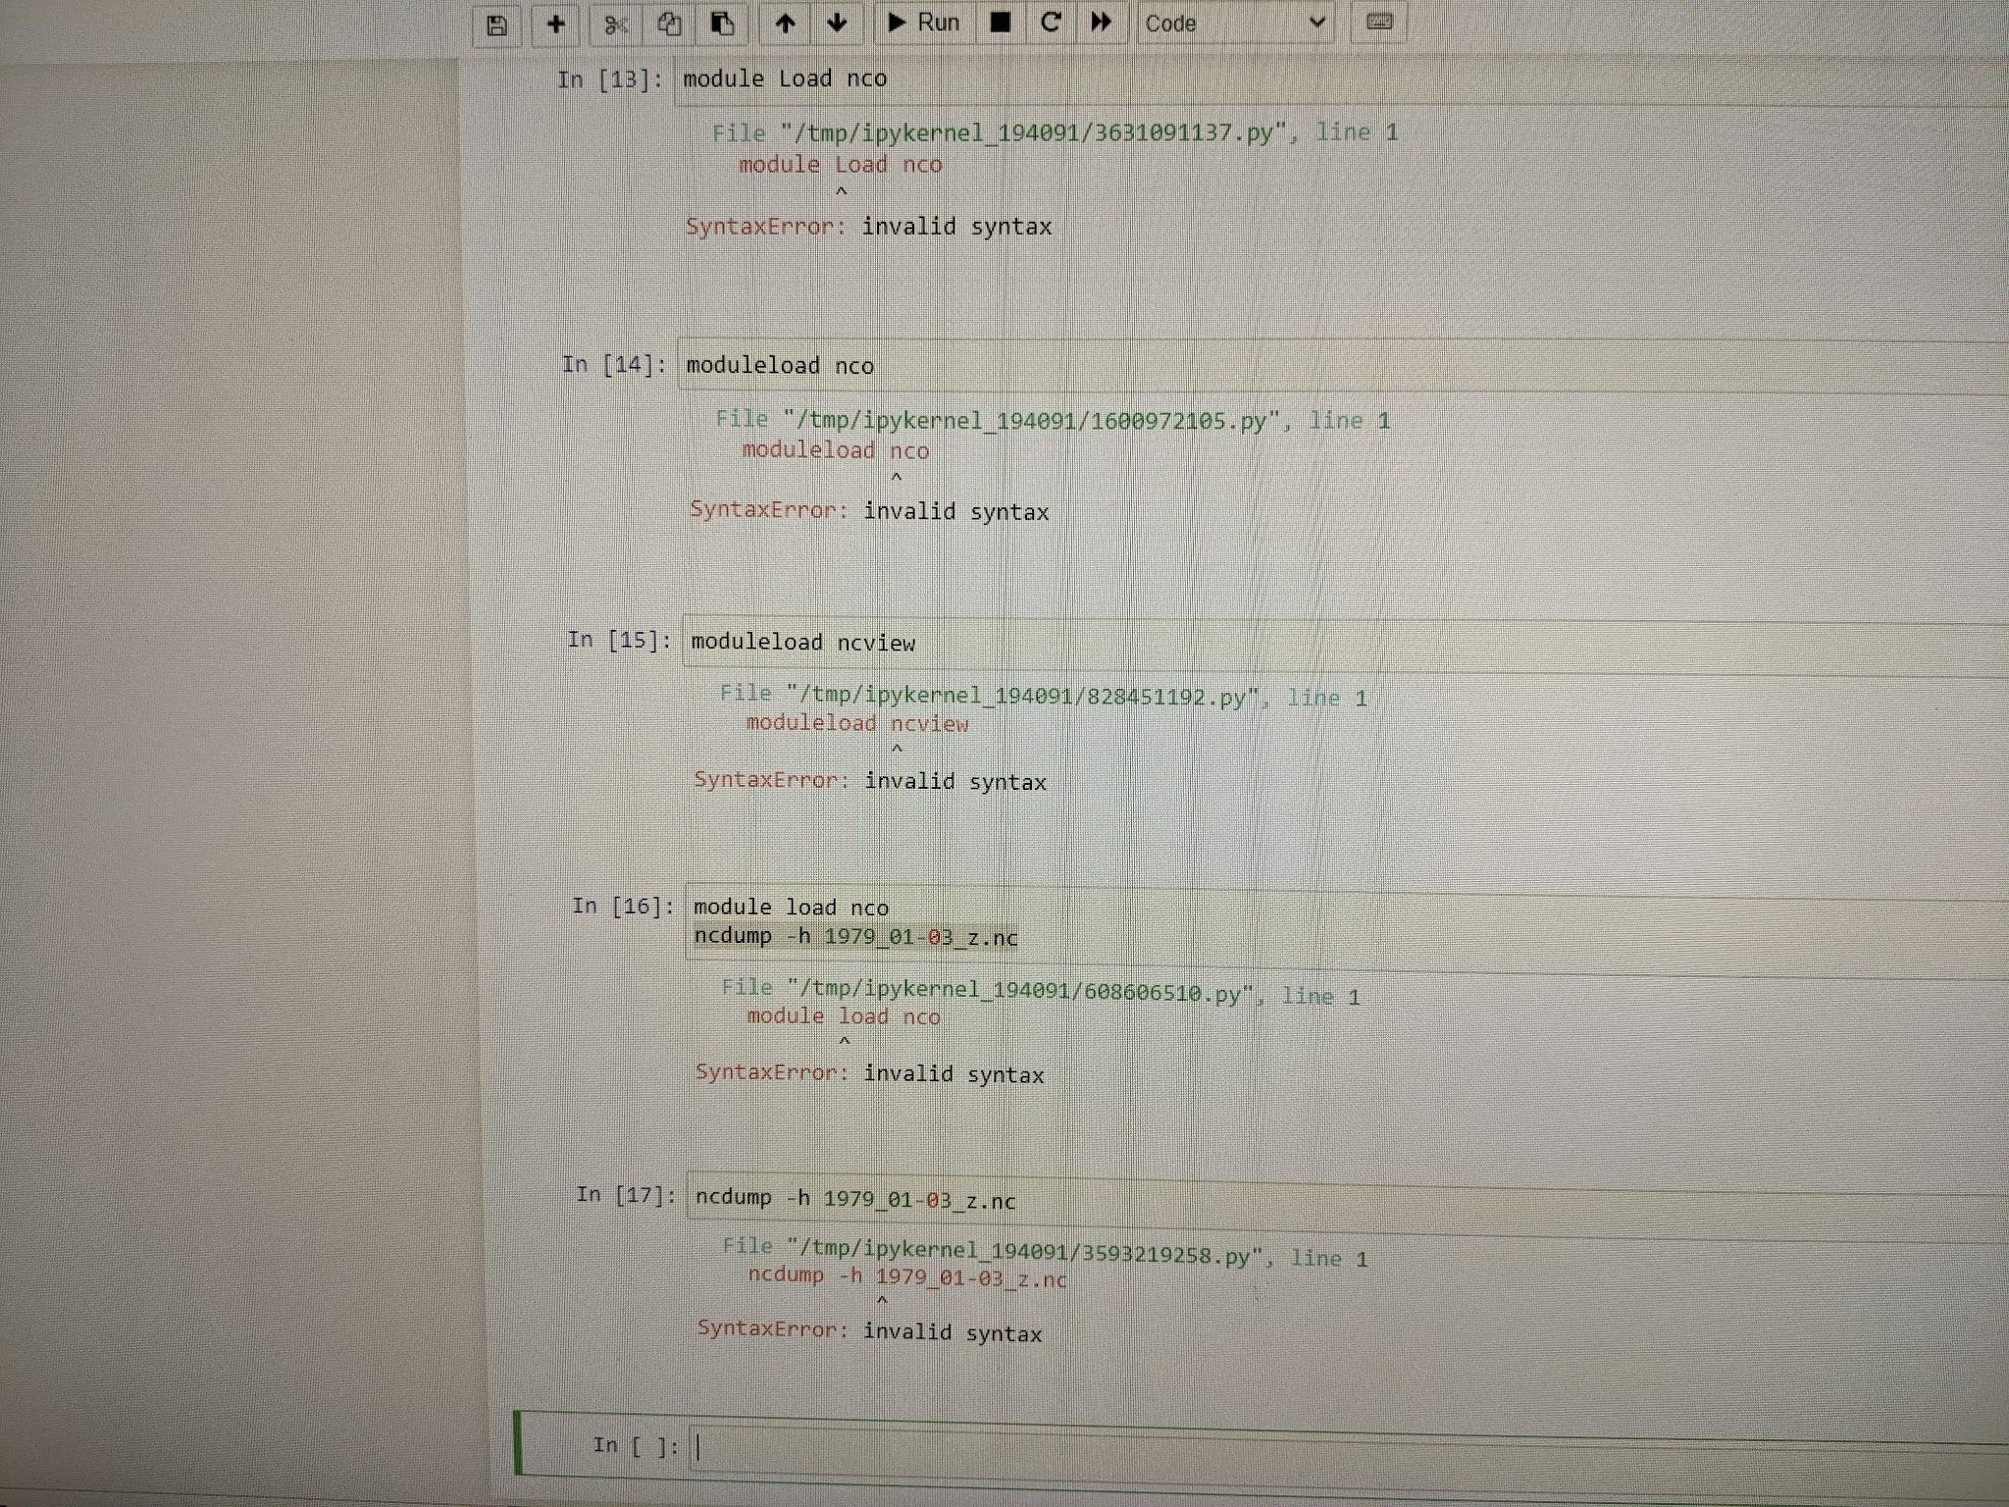

3)

1. The MACDA Data which stands for Mars Analysis Correction Data Assimilation is a reanalysis dataset which covers four years of the martian atmospheric data (MY 24 - MY 27). It is constructed by TES (Thermal Emission Spectrometer) and MGS (Mars Global Surveyor) and is 63 files in total. Each of these files covers 30 Martian sols with each sol spanning 24 Martian hours and data being captured every two hours. This dataset covers a limited number of variables including “co2ice” (surface_frozen_carbon_dioxide_amount), “Ls” ("solar_longitude), latitude and longitude, etc.